General equilibrium model
Our main aim through the GEM is to provide a constraint to the gdp growth, we can consider a sort of limit of growth of the components subject to limitations of budget, investments etc. The increase in GDP has to be limited because, as a developing country we have tight budget constraints, also unconditional increase in labor is also not possible, further increasing the gdp also involves usage of fuel resources (to increase production, manufacturing) which might lead to increased ${CO}_{2}$ emissions. So, all these components have to be optimized to obtain a general equilibrium model.
So, for final model, we intend to find an optimal point by employing iterative measures. The factors used will be Capital, Investment, Labor for deriving the constraint.*
So in order to obtain such a constraint after obtaining our components we have to get an Input-Output matrix which basically provides a point where equilibrium obtained by equalizing demand and supply. Alternatively, to find a optimal point we may also use a graphical method similar to the demand=supply basic model and find a region in the graph where all the points together may provide an optimal solution.
Followed by this, we require a utility function.
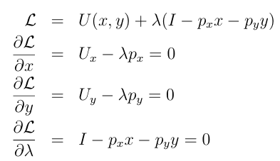
The above process is Lagrange multiplier, where we differentiate the Utility function after applying the constraint on the maximization production function (px+py<I). Thus we can obtain the individual cap on each component of gdp.
#What do we require?
- Investment data, income per capita data
- A production function of gdp in terms of Investment, income, labor and consumption, wherein they are all interrelated.
- A method to find the optimal values.
- A utility function where gdp is given as function of gdp components
- OR, find a way to make I-O matrix that will help just get the equilibrium point?

New

